Date: 04.07.2025
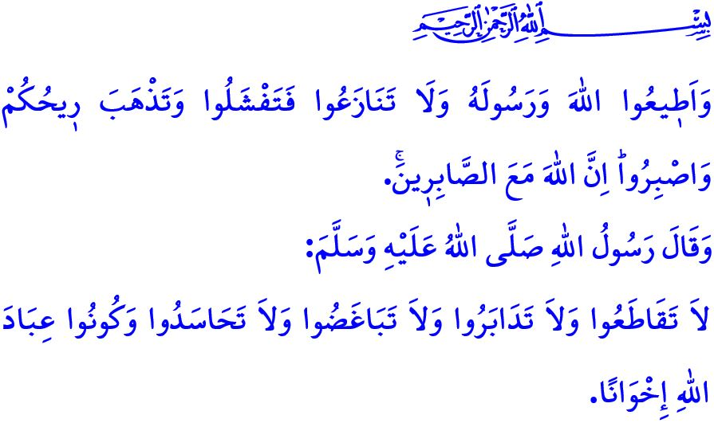
LET US LOOK UPON THE PAST WITH REFLECTION AND TOWARD THE FUTURE WITH FORESIGHT
Honorable Muslims!
We are in the month of Muharram, which our Prophet (saw) described as “worthy of reverence”. Tomorrow is the tenth of Muharram, the Day of Ashura. Our Prophet (saw) said, “The most virtuous fast after the fast of Ramadan is that observed in the month of Allah, Muharram.”, and advised us to fast on the Day of Ashura together with either the day before or the day after.
Dear Believers!
With the month of Muharram, which marks the beginning of the Hijri year, we are once again reminded to duly observe the commands and prohibitions of our Lord, and to adorn ourselves with the noble character of the Messenger of Allah (saw). Our beloved Prophet Muhammad (saw) is a messenger of mercy sent to all of humanity. We have learned from that Blessed Prophet (saw) to adopt virtues such as respect, love, and kindness as our guiding principles, and to cleanse ourselves of negative emotions and thoughts such as hatred, enmity, and envy. He showed us how to honor human dignity, to refrain from attacking what others hold sacred, to avoid stirring discord and corruption in society, to bring joy to the faces of orphans and the oppressed, and to grant women and children the worth they truly deserve.
Dear Muslims!
What befits us today is to hold fast to the Sunnah of our Prophet (saw) and to love him above all people and all things. We must recognize that showing him reverence and honor is both a command of our Lord and a necessity of our faith. It is to remain wholeheartedly devoted to the verse: وَلَاتَفَرَّقُواۖ وَاعْتَصِمُوا بِحَبْلِ اللّٰهِ جَم۪يعاً “Hold firmly together to the rope of Allah and do not be divided.” It is to refrain from every word, attitude, and action that would harm our unity and solidarity. It is to remain vigilant against all malicious forces, both within and without, who attack our faith, our values, and all that we hold sacred.
Honorable Believers!
The day of Ashura also calls to mind the sorrowful incident in which over seventy Muslims, including the beloved grandson of the Messenger of Allah (saw), Husayn, whom he described as “My flower, my sweet basil in this world.”, were martyred at Karbala. Alas, today Muslims are still beset by oppressors, enemies of Islam and humanity, who continue their tyranny in many lands, foremost among them Gaza, precisely because we have failed to draw the necessary lessons from this tragedy and to act with the consciousness of brotherhood and a unified ummah.
In such times, what befits us is to look upon the past with reflection and to look toward the future with foresight; to hold fast to the life-giving principles of Islam; to stand as one against the vile attacks on the Qur’an and our Prophet (saw). It is to strengthen our bonds of brotherhood, taking to heart the hadith: “Do not sever ties with one another, do not turn your backs on one another, do not harbor hatred or envy. O servants of Allah, be brothers.” It is to obey the divine command: وَاَعِدُّوا لَهُمْ مَا اسْتَطَعْتُمْ مِنْ قُوَّةٍ “Prepare against them what you ˹believers˺ can of ˹military˺ power...” by striving to be strong in every field, material and spiritual alike, foremost in knowledge, science, and technology.
On this occasion, I remember with mercy, gratitude, and deep respect our beloved Husayn, the commander of the martyrs, and all those who gave their lives for truth, justice, and our sacred values.
Dear Brothers and Sisters!
For some time now, we have been engaged in a collective struggle against forest fires. Unfortunately, our lungs are burning. Let us all refrain from any actions that could cause fires, especially in our forests and open lands. Let us heed the warnings of the authorities. May our Almighty Lord protect our nation and our country from all disasters and calamities.

I would like to conclude this Friday's khutbah with Verse 46 of Surah al-Anfal: “Obey Allah and His Messenger and do not dispute with one another, or you would be discouraged and weakened. Persevere! Surely Allah is with those who persevere.”

Muslim, Siyam, 203.
Muslim, Siyam, 202.
Ibn Hanbal, I, 240.
Ali ‘Imran, 3/103.
Tirmidhi, Birr, 11.
Tirmidhi, Birr wa Sila, 24.
Anfal, 8/60.
Anfal, 8/46. General Directorate of Religious Services

